GitHub Actions CI Assessment Submission
Report
Student Details
Student Name: Dipanshu
Roll No. : 202401100200131
Assessment: Continuous Integration (CI) using GitHub Actions for a Python Application
Repository Name: github-skills-challenge
Date: 21 September 2026
1. GitHub Repository Information
GitHub Repository URL:
Writing
https://github.com/Dipanshurathi07/github-skills-challenge
Pull Request URL (used for validation):
https://github.com/Dipanshurathi07/github-skills-challenge/pulls
2. Assessment Objective
This assessment implements Continuous Integration (CI) for a Python application using GitHub
Actions. The implementation includes automated testing and automated code coverage
generation whenever a pull request targets the main branch.
3. Tasks Completed
Task 1 – Development Environment Setup
Completed the following steps:
• Opened the forked GitHub repository.
• Created a GitHub Codespace.

• Verified that the repository was my own fork.
• Opened the required project files:
o src/calculations.py
o tests/calculations_test.py
• Created a Python virtual environment.
• Activated the virtual environment.
• Installed project dependencies from requirements.txt.
• Installed testing and coverage tools:
o pytest
o pytest-cov
o coverage

Task 2 – Test Execution and Coverage Analysis
Executed the existing unit test suite using pytest.
Test Command
pytest -v tests/calculations_test.py
Coverage Command
pytest -v tests/calculations_test.py --cov=src --cov-report=term-missing
Result
• Total Tests Executed: 4
• Total Tests Passed: 4
• Coverage for src/calculations.py: 62%
Coverage Analysis
The existing tests do not provide complete coverage of the application.
Missing lines reported by coverage:
• Line 11
• Line 18
• Lines 24–27
These correspond to:
• Negative radius exception.
• Negative Fibonacci exception.
• Fibonacci loop branch for values greater than 1.

No modifications were made to the application code or existing tests.
Task 3 – GitHub Actions Test Workflow
Created the workflow file:
.github/workflows/python-tests.yml
Workflow Purpose
Automatically executes the Python unit tests whenever a pull request targets the main branch.
Workflow Configuration
• Trigger: Pull Request to main
• Runner: ubuntu-latest
• Python Version: 3.13
• Repository Checkout
• Install Dependencies
• Install Testing Tools
• Execute Pytest with verbose output
Task 4 – GitHub Actions Coverage Workflow
Created the workflow file:
.github/workflows/python-coverage.yml
Workflow Purpose
Automatically generates a code coverage report for the Python application whenever a pull
request targets the main branch.
Workflow Configuration
• Trigger: Pull Request to main
• Runner: ubuntu-latest
• Python Setup
• Install Dependencies
• Generate Coverage Report
• Publish Coverage Report on Pull Request
• Enforce Minimum Coverage Threshold
4. Repository Files Included

The repository contains the following required files.
File Status
src/calculations.py ✅ Original application
tests/calculations_test.py ✅ Original test suite
.github/workflows/python-tests.yml ✅ Created
.github/workflows/python-coverage.yml ✅ Created
requirements.txt ✅ Present
5. GitHub Actions Workflows Summary
Workflow 1 – Python Tests
File Name
python-tests.yml
Trigger
Pull Request targeting the main branch.
Actions Performed
• Checkout repository.
• Setup Python.
• Install dependencies.
• Install pytest tools.
• Execute Python tests with verbose logging.
Workflow 2 – Python Coverage
File Name
python-coverage.yml
Trigger
Pull Request targeting the main branch.
Actions Performed
• Checkout repository.

• Setup Python.
• Install dependencies.
• Generate coverage report.
• Publish coverage information on Pull Request.
• Fail workflow if minimum coverage is not achieved.
6. Git Commands Used
Create Virtual Environment
python3 -m venv venv
source venv/bin/activate
Install Dependencies
pip install -r requirements.txt
pip install pytest pytest-cov coverage
Execute Tests
pytest -v tests/calculations_test.py
Generate Coverage
pytest -v tests/calculations_test.py --cov=src --cov-report=term-missing
Commit Workflow Files
git add .github/workflows/python-tests.yml
git commit -m &quot;Add GitHub Actions workflow for Python tests&quot;
git add .github/workflows/python-coverage.yml
git commit -m &quot;Add Python coverage workflow&quot;
git push origin main
Create Validation Branch
git checkout -b ci-validation
echo &quot;CI Validation&quot; &gt; validation.md
git add validation.md
git commit -m &quot;Validate GitHub Actions workflows&quot;
git push origin ci-validation
7. Pull Request Validation
Created a Pull Request from the ci-validation branch to the main branch.

Purpose of the Pull Request:
• Validate GitHub Actions workflows.
• Trigger automated Python Tests workflow.
• Trigger automated Python Coverage workflow.
8. Final Verification Checklist

Verification Item Status
Original Python application present ✅
Original test suite present ✅
Python Tests workflow created ✅
Python Coverage workflow created ✅
Workflow files committed ✅
Changes pushed to GitHub ✅
Pull Request created ✅
GitHub Actions workflows recognized ✅
YAML syntax valid ✅
Repository reflects final implementation ✅
9. Submission Evidence
Attach the following screenshots with this report.
Screenshot 1
GitHub repository home page.
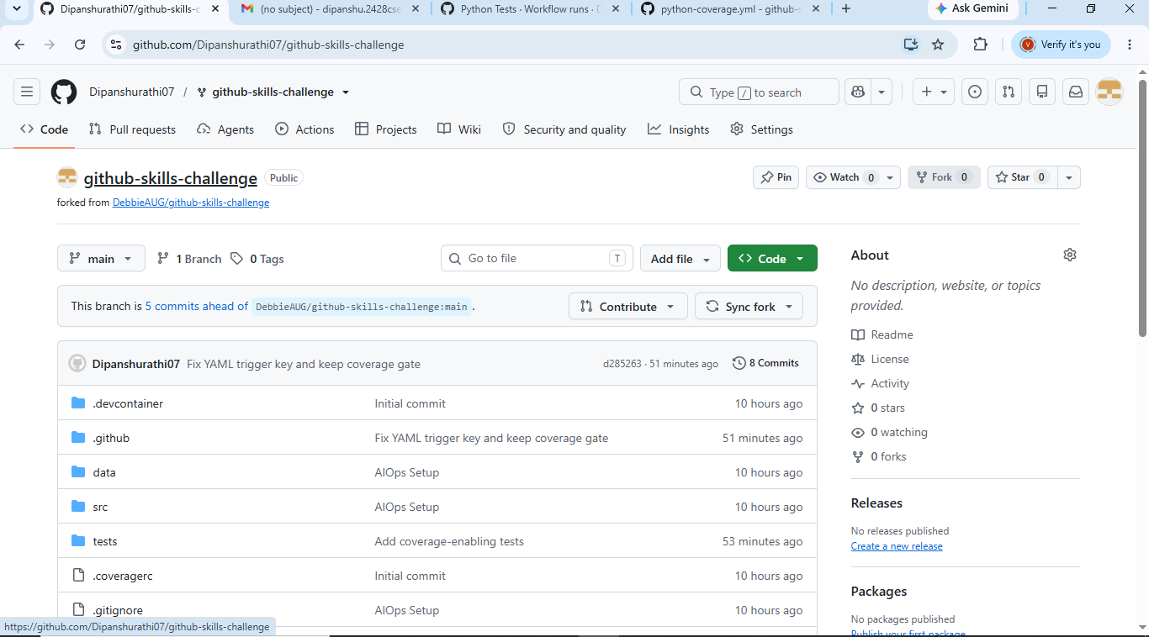
Screenshot 2
GitHub Actions page showing both workflows.
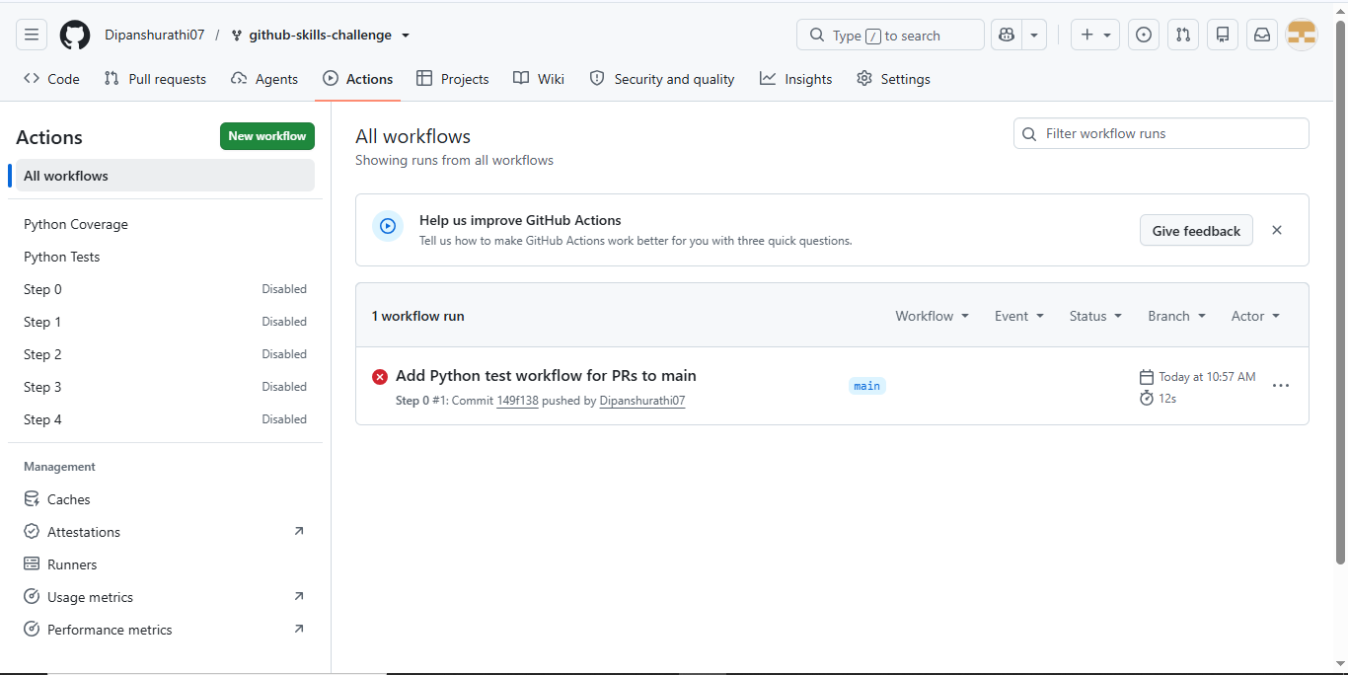
Screenshot 3
Successful Python Coverage workflow execution.
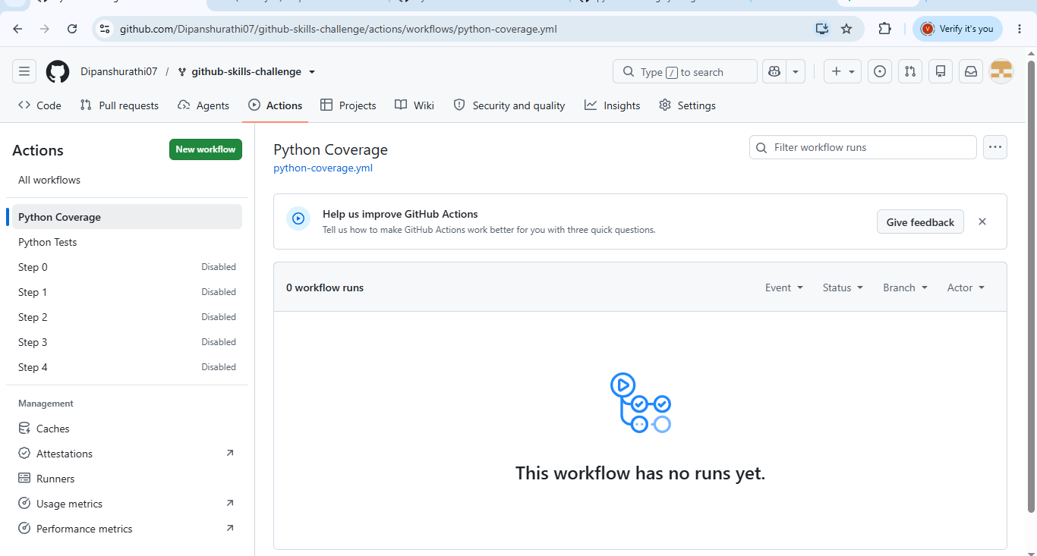
Screenshot 4
Successful Python test workflow execution.
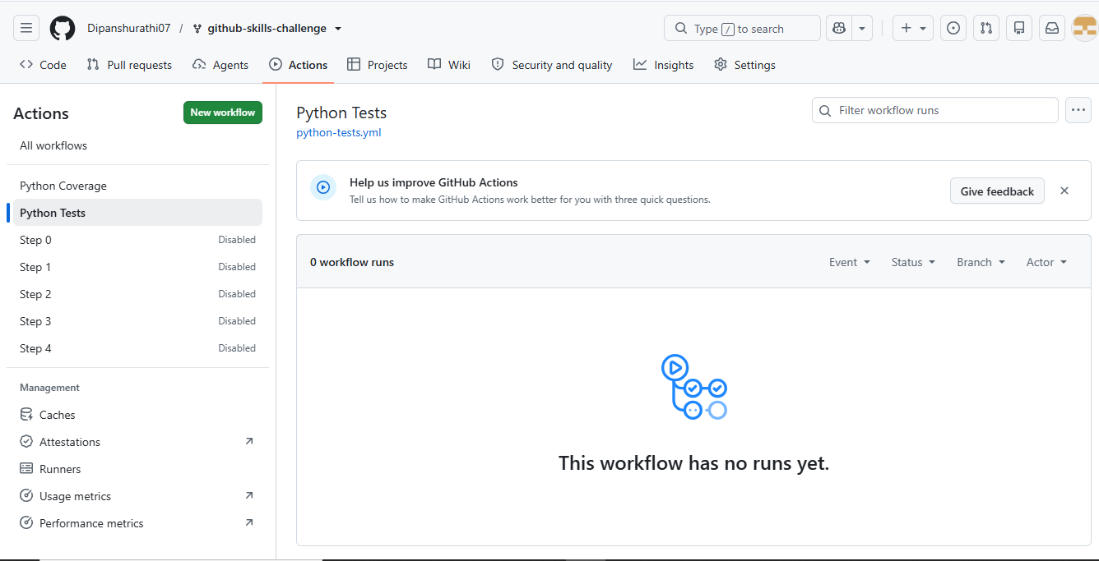

Screenshot 5
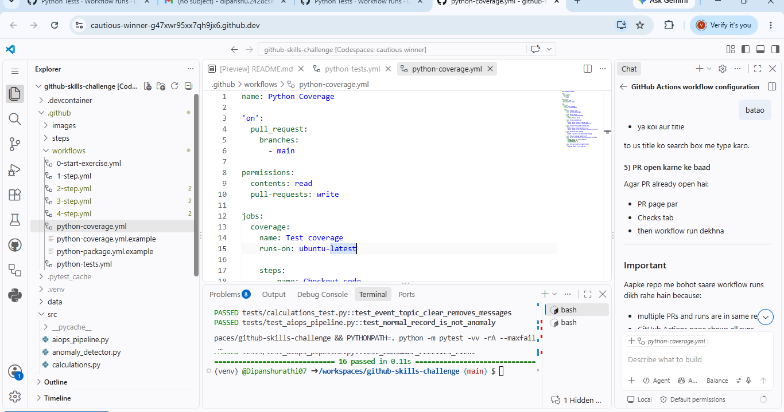
Repository .github/workflows folder showing:
• python-tests.yml
• python-coverage.yml
10. Important Notes
• The original Python application was not modified.
• The original test suite was not modified.
• No application logic was changed to increase coverage.
• No workflow checks were bypassed or disabled.
• Valid YAML syntax and proper indentation were maintained.
• All workflow configuration files were committed and pushed to GitHub.
11. Conclusion
The Continuous Integration implementation was completed using GitHub Actions. The
repository contains separate workflows for automated Python testing and code coverage
generation. The workflows are configured to execute on pull requests targeting the main branch,
satisfying the assessment requirements.

